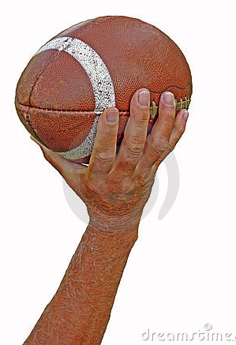

- Reach arm back to ear

- Elbow up

- Face the target (person you are throwing to)

- Extend your free arm in front of you for balance; point the arm and hand at your target.

- Step with opposite foot

- Grip the football by interlacing your fingers between the football's laces and seams.

- Protect the ball by cradling it with two hands, and hold it just under your chin as you step back to throw.

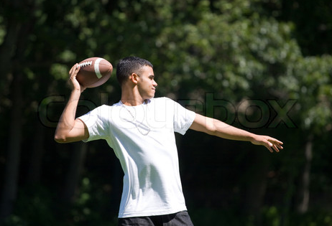

- Release the ball when your arm is slightly above your head and out to the side.

- Snap your arm forward and follow through with your shoulders and hips.

- Add spiral to the ball by flicking your wrist and fingers just as you release it.

- Finish with your index finger pointing forward and down, and with your palm facing the ground.

